Consider a disk queue with requests for I/O to blocks on cylinders

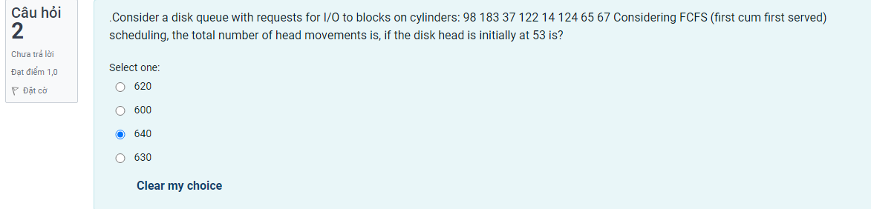

Error handler codes, to deal with uncommon issues are

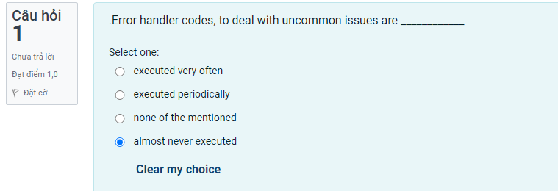

Consider the following page reference string

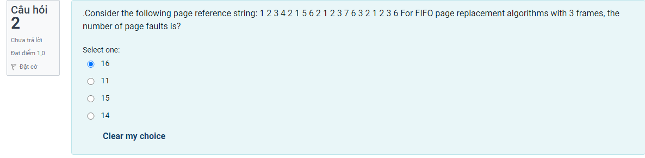

Consider a machine in which all memory reference instructions have only one memory address

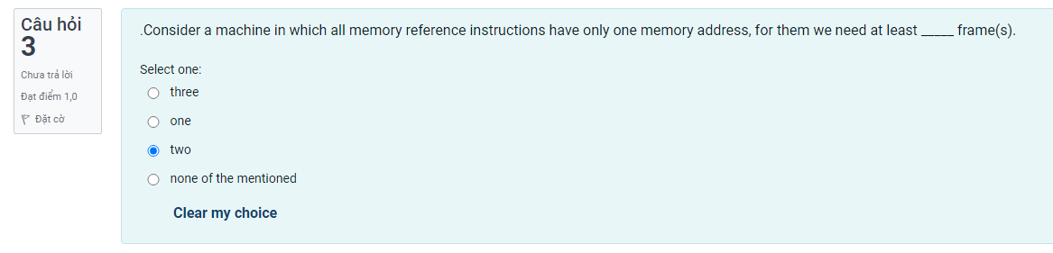

Which of the following is TRUE

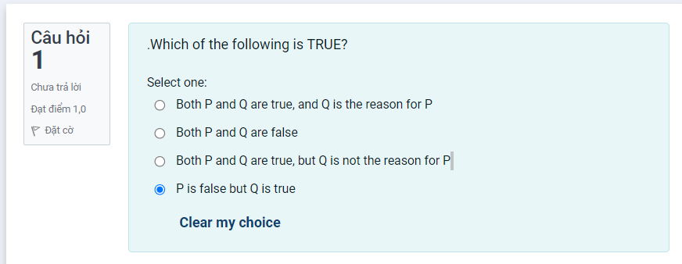

In virtual memory. the coder



A FIFO replacement algorithm associates with each page the



In this situation, what does the valid - invalid bit mean



A memory page containing a heavily used variable that was initialized v

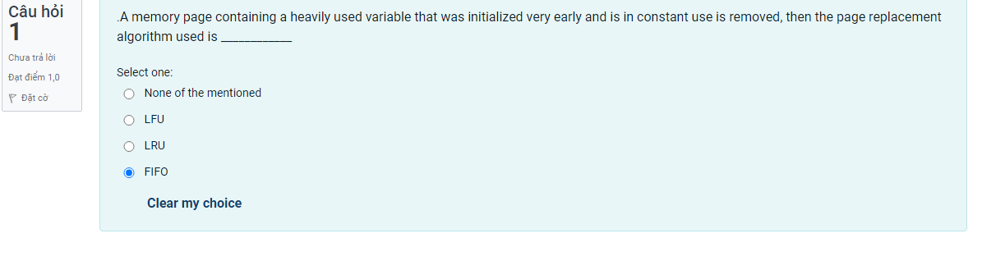

When a page needs to be replaced, which algorithm selects the one that hasn't been



Locality of reference denotes that a process

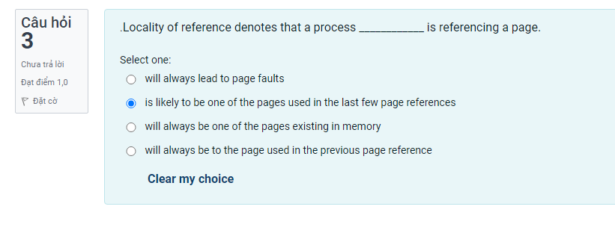

The page replacement working set concept is based on the

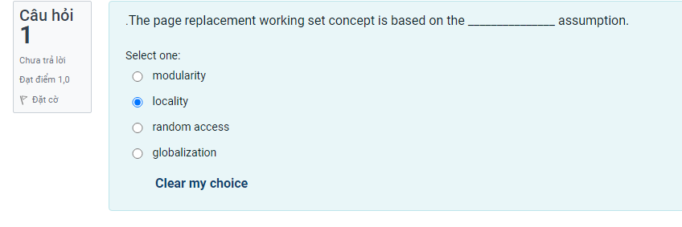

If the working set window is inadequate

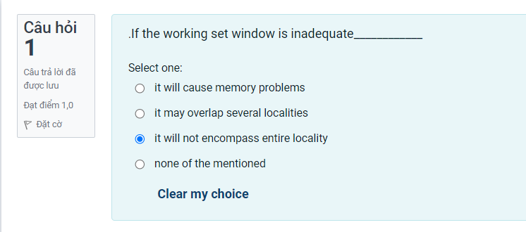

replacement allows each process to only select from its own set of allocated frames.



The aim of creating page replacement algorithms is to

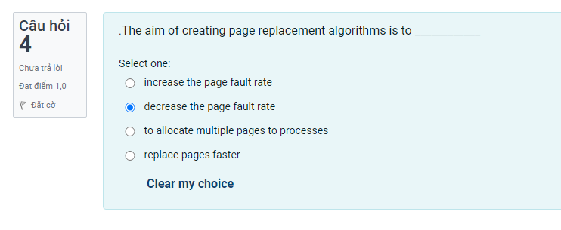

What is the Optimal page – replacement algorithm?

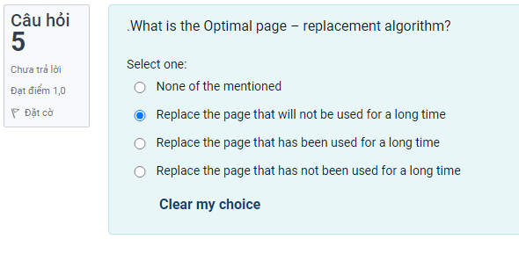

Locality is



One problem with the global replacement algorithm is that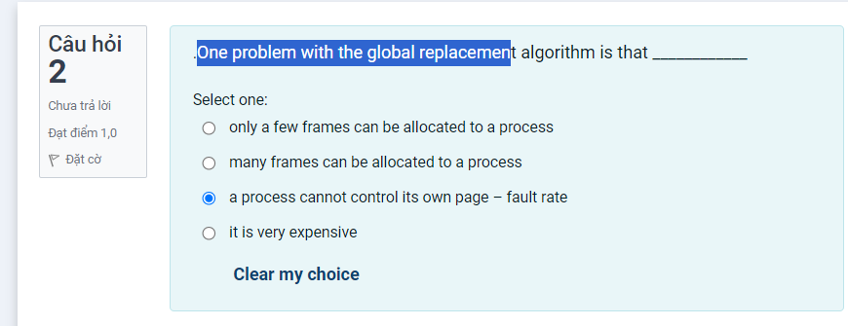

Whenever the working set window is too big

There is swap space in



Compared to page replacement algorithms, segment replacement techniques

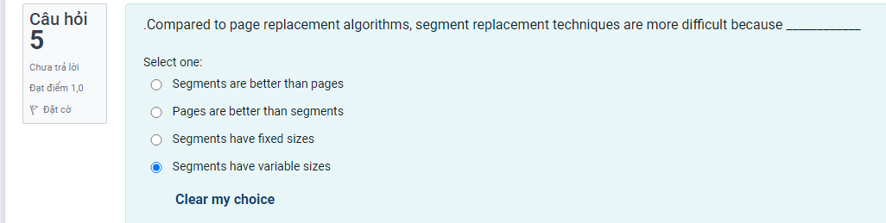

usually implements virtual memory



When a page fault occurs before an executing instruction

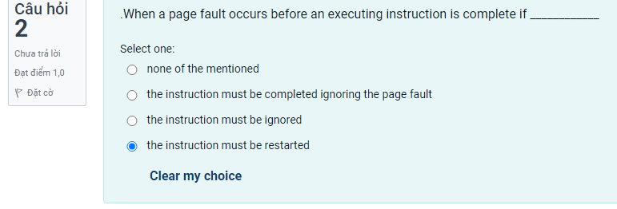

CPU use ______________ when there is thrashing.

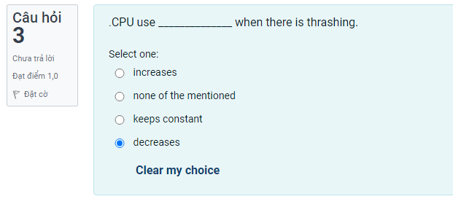

The pager is focused on the

Consider the following page reference string: 1 2 3 4 2 1 5 6 2 1 2 3 7 6 3 2 1 2 3 6 For LRU page replacement algorithm with 5 frames

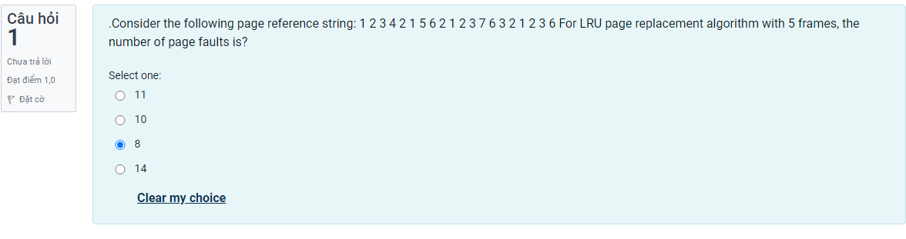

.In the ______ algorithm, the disk arm goes as far as the final request in each direction, then rev



A program is generally composed of several different localities,

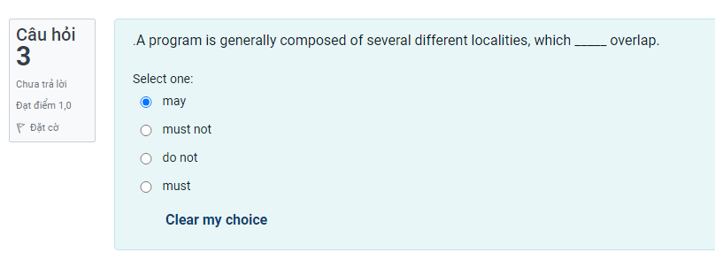

For 3 page frames, the following is the reference string:



Virtual memory makes it possible for

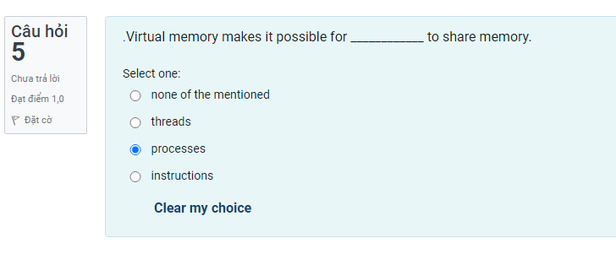

Whenever the page fault rate is minimal

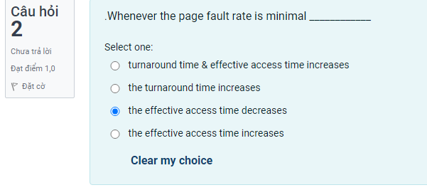

replacement allows a process to select a replacement frame from the set of all frames



Users _______ that their processes are running on a paged system.

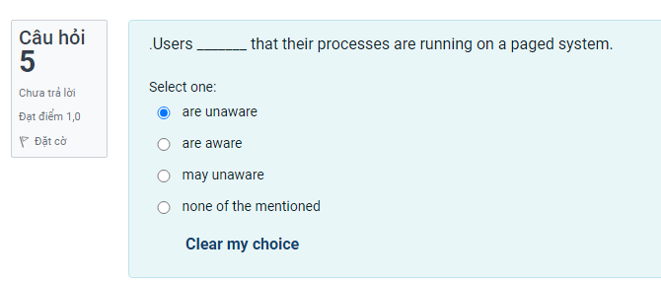

What are the two methods of the LRU page replacement policy that can be implemented in hardware



Whenever a process starts up but has no pages in memory

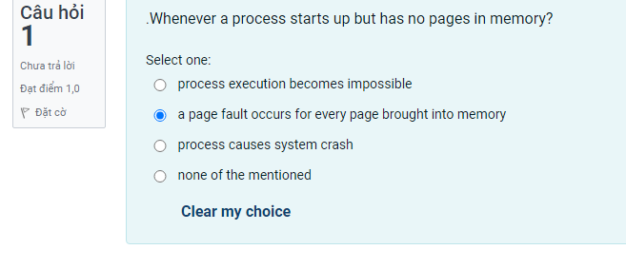

When does a page fault occur?



If no frames are free, _____ page transfer(s) is/are require



Optimal page – replacement algorithm is difficult to implement

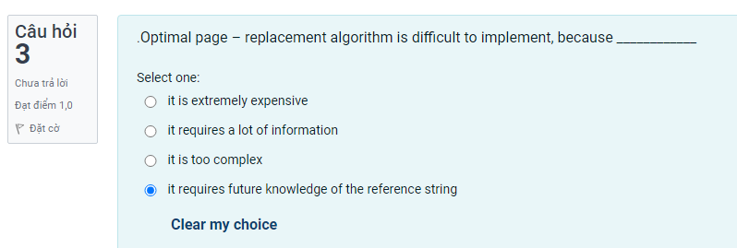

Employing a pager

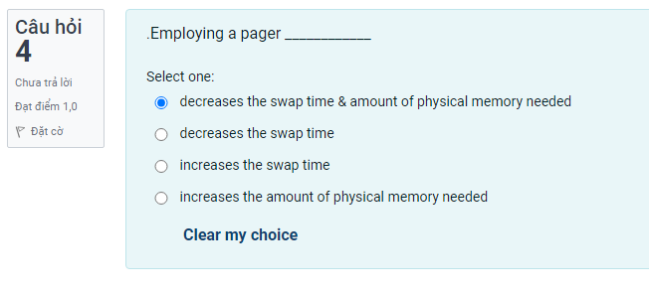

SSTF algorithm, like SJF __________ of some requests

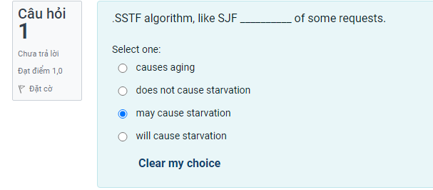

If a process is thrashing

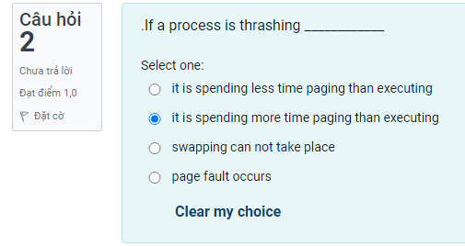

A pager is interested in specific process _________, whereas a swapper manipulates

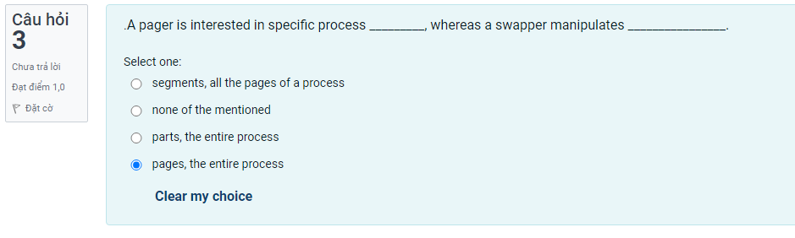

Random access in magnetic tapes is _________ compared to magnetic disks

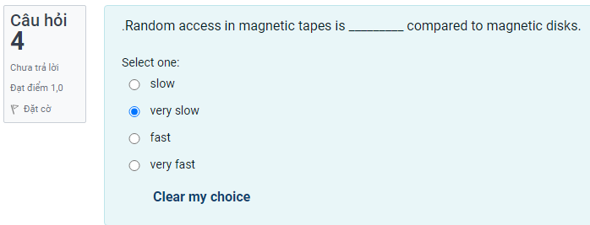

The working set at time t1 (….7 5 1) is

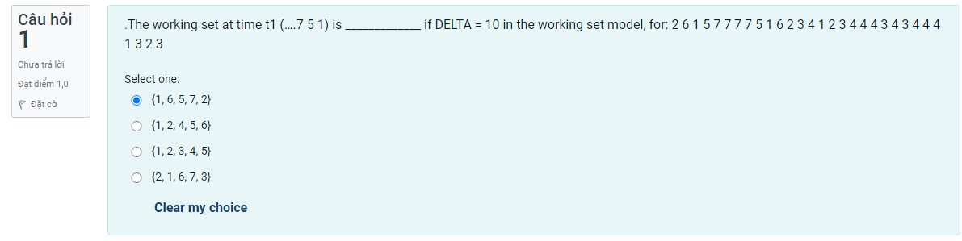

If a process needs I/O to or from a disk,

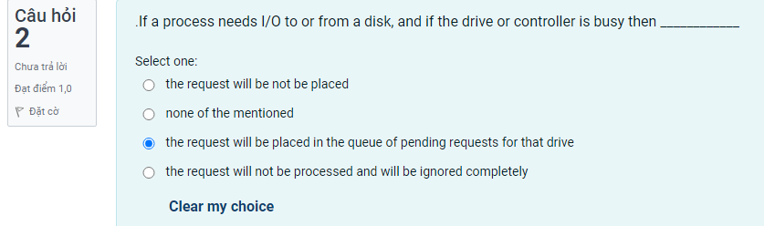

 replacement generally results in greater system throughput.



The algorithm in which we split m frames among n processes



When a program tries to access a page that is loaded in physical memory 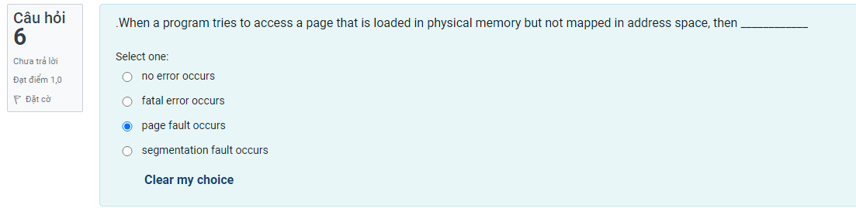

When a page needs to be replaced in the FIFO page replacement process



When a page fault happens, the interrupted process's state is



The instruction being carried out must be in



A subroutine's call signals

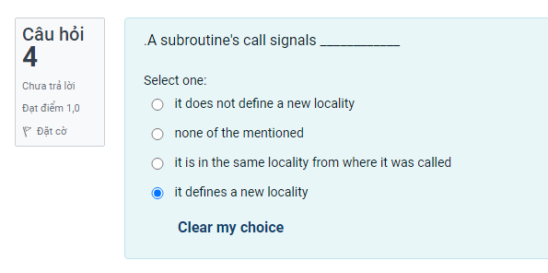

is a concept where a process is copied from the secondary memory into the main memory as needed.

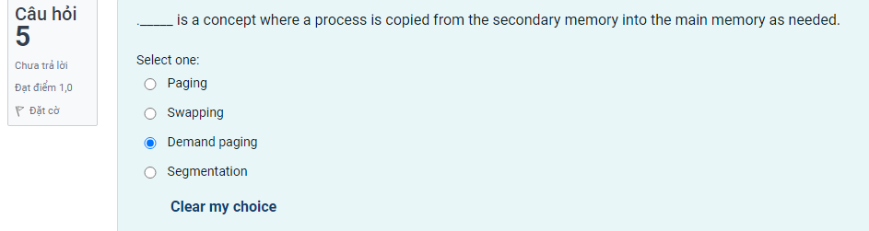

Which of the following page replacement algorithms suffers



If the overall size of the working set exceeds the total number of frames available

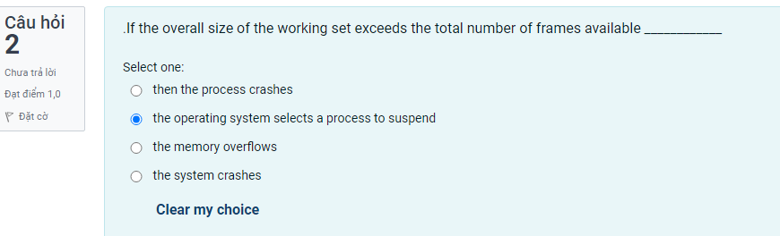

The advantages of being able to run a program that is only partially



With either equal or proportional algorithm



Whenever a process needs I/O to or from a disk it issues a

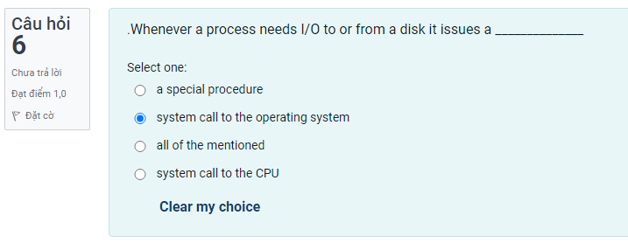

 has a direct correlation with effective access time

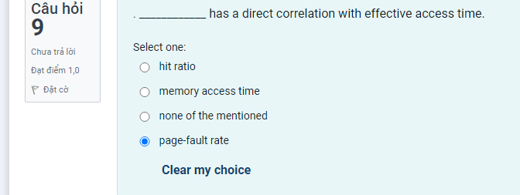

In the _______ algorithm, the disk head moves from one end to the other, servicing

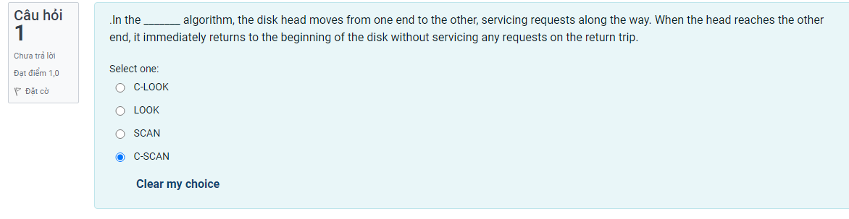

In the ______ algorithm, the disk arm starts at one end of the disk and moves toward the other end

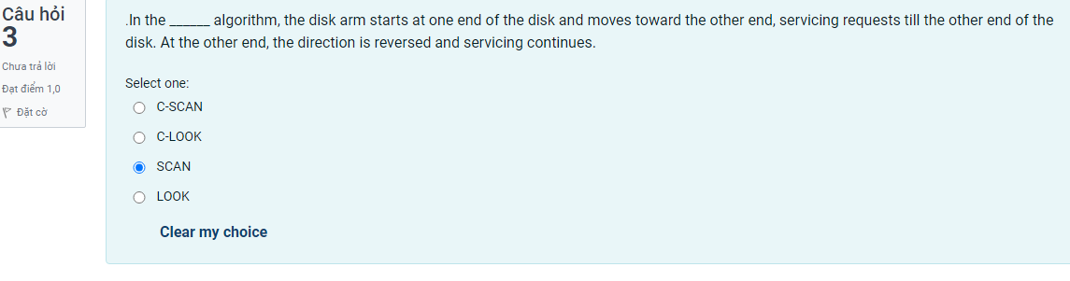

The algorithm in which we allocate memory to each process according

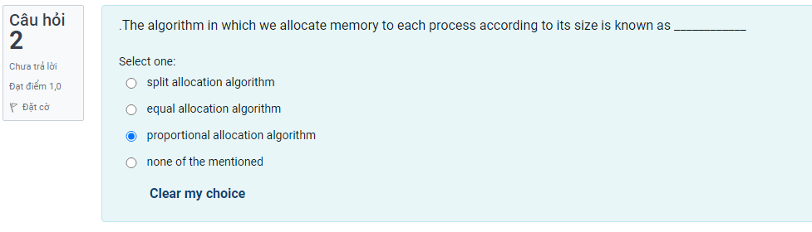

The maximum number of frames per process is defined by

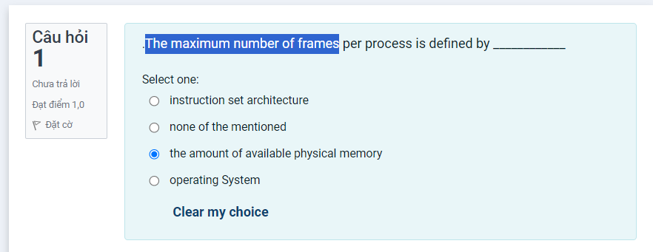

.When a page is selected for replacement, and its modify bit is set



Magnetic tape drives can write data at a speed ________ disk drives.

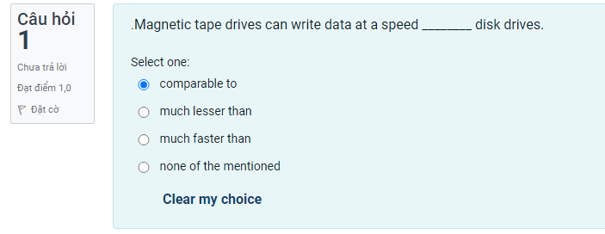

The choice of _____________________ affects the working set's precision.(B đúng)

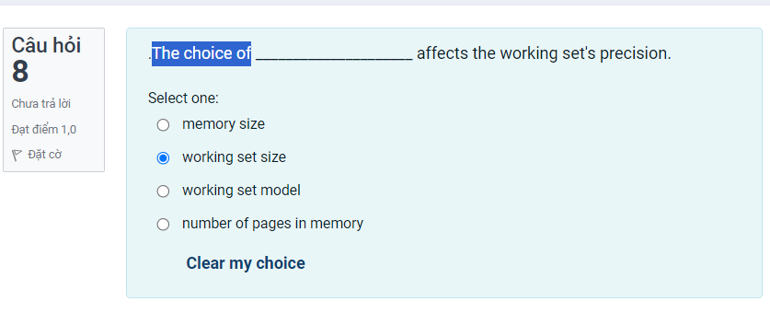

Consider a disk queue with requests for I/O to blocks on cylinders:

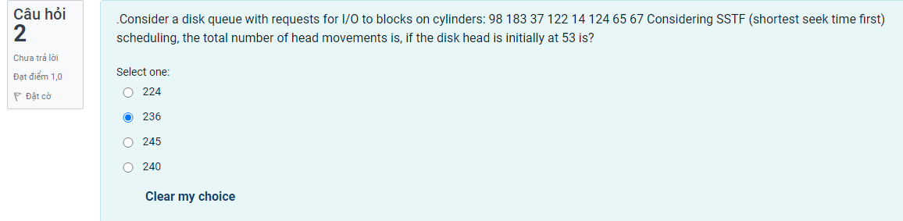

On media that use constant linear velocity (CLV), the _____________ is uniform.



A process refers to 5 pages, A, B, C, D, E in the order : A, B, C, D, A, B, E, A, B, C, D, E

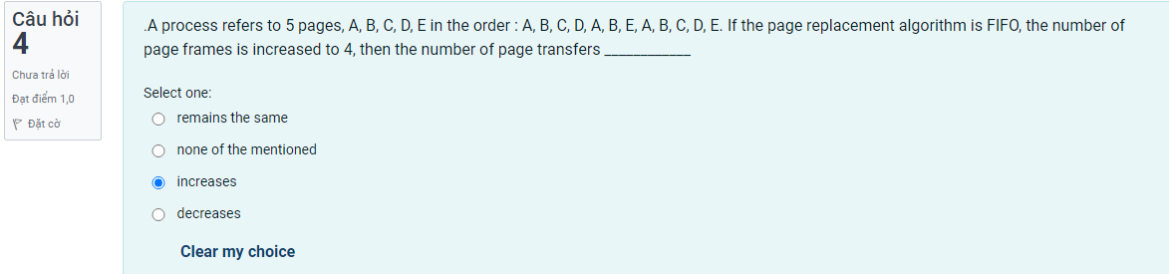

If a process is thrashing

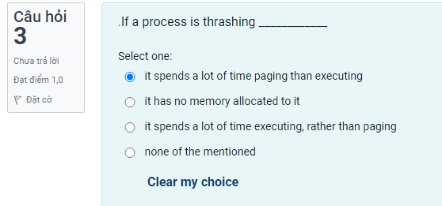

 is possible thanks to virtual memory.

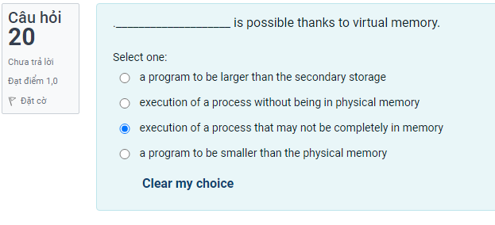

The minimum number of frames to be allocated to a process



A process refers to 5 pages, A, B, C, D, E in the order : A, B, C, D, A, B, E, A, B, C, D, E

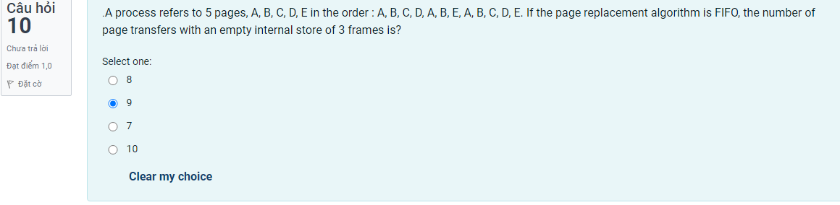

.LRU page – replacement algorithm associates with each page the

